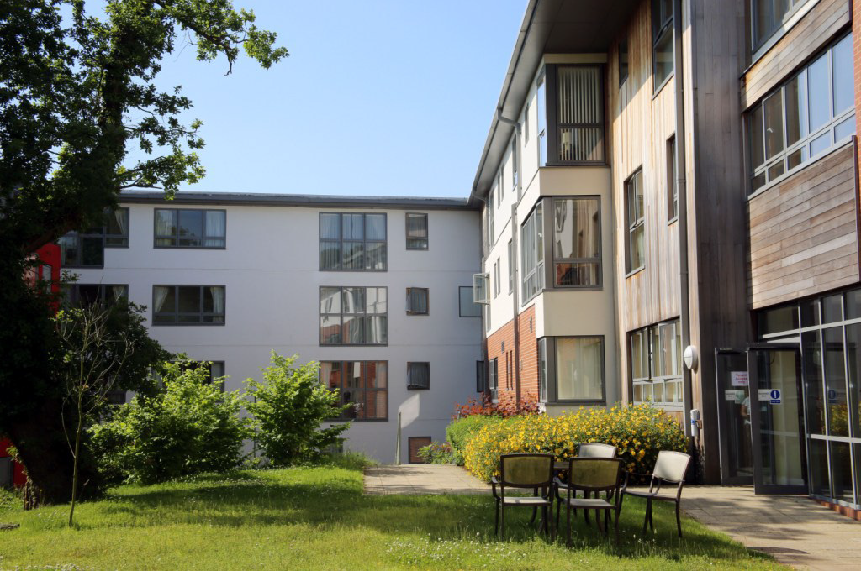

**Hazel Court Care Home – 120 Bed Care Home**

**Design, manufacture and erection This purpose-built extra care facility in the Sketty area of Swansea. Constructed in 2008, Seven Oaks supplied the timber frames, cassette floors and flat roof structure for 120 apartments set over three blocks, with the highest block covering four storeys.**

**The extra care facility has a wide range of communal facilities, which are widely used by both tenants and the wider community including Gym Therapy Room, Exercise Room, Community Hall,Training / Meeting Room, Craft and Hobbies Room, Library / IT Suite, Restaurant,Shop and Hairdressing Salon.**

**Type of Project - Extra Care**

**Client – Cowlin Construction**